

Interaction and Visualization

Choosing a holiday

Lecturer: Simon

Course Id: CSD4030

Student Name: Bhagyashree Patel

Student Id: M00555265

Term: 1

Table of Contents

Chapter 1: Introduction……………………………2

Chapter 2: Literature review……………………...3

Chapter 3: User research…………………………4

Chapter 4: Prototype………………………………6

Chapter 5: User evaluation……………………….10

Chapter 6: Discussion……………………………..12

References………………………………………….13

Chapter 1: Introduction

My topic is choosing a holiday. First think i decide what people would like to do. People like to do mostly sport, cultural and wildlife activities. Consider a place that has rafting, skydiving, and Trekking. If you like to go for historical, ancient places like Egypt, China, and Rome and so on might be right for you. Beach destinations are popular for relaxation. Consider camping when traveling with children or family. Moreover, if the person thinking of taking some time out to take a holiday or to travel, where do they start? With so much exposure to adverts, Trip reviews, recommendations from friends and suggestive booklet it can be a challenging prospect to choose a destination (Place), the purpose is that what to do while they are there. Maybe that is why so many of us settle for an all-inclusive package that takes away the problem of planning and organising the trip. But planning a holiday can - and should - be a fun part of the whole experience. Planning a holiday can be an exciting time.

The aim of this study is to examine the factors influencing the choosing a holiday, and how important the role of budget, activities, and destination is in the decision making process.

The most part of time in this project was spent on different kind of researches, literature studying and evaluations. So basically the following objectives were identified before starting the project:

* There is a need to made prototype first and then see the user experience.
* Prototype analysis and search of possible ways to improve website functionality and design in future. In addition, the discussion and user evaluation are the most important objectives.

Chapter 2: Literature review

Any successful software must be developed based on user preferences. But in our case we have to first make website and then evaluate that prototype. So, the terms user experience usability describe person’s emotions and experience about using a particular website, system, software. And, the reason is that multiple persons use online booking of holidays, User experience is a key objective of Literature Research for this project.

The impacts of holiday reflect the fact that it is an activity of economic importance. In addition, it is impossible to say definitely, what should be done in order to make user get only positive emotions.

Important things is:

* Ensure usability of website.
* Respect user privacy and security. Personal data must be always protected.
* Provide several choice for the user.

Important is user expectations. Holiday should be something new feature or design implementation in order to excite the user. The ISO 9241-210 standard recommends characteristics to improve user experience:

* User-centred evaluation refined design
* Consideration of the whole user experience
* Involvement of users throughout design and development.
* Explicit understanding of user and tasks.

The best way to improve the interface of an application is to ask user directly about what is the pros and cons of the interface. For this purpose, a number of techniques to communicate with user exits. It can be done in form interview or questionnaires. Both of these methods can involve direct communication with the user or not. The form of communication is decisive factor to get correct result from users.

According to the ISO 9231 standard, usability dimensions are:

* Effectiveness
* Efficiency
* Satisfaction

Chapter 3: User research

The number of choosing a holiday websites exists. Users already have experience about using online holiday booking.

Firstly, the user research was about getting the way how a user is uses to choose or book a holiday. So, the purpose is that the software BBFlash (Free online Screen Recorder) was used to record screen and audio as well for observation.

We observe different participant while selecting holiday from the already created website.

In addition, two methods can be applied to perform user research directly – Interview or Questionnaire and this two are main thing in our project. For this project, live interview was selected as the method to get the information from the users (participant). In our opinion, live communication is the good idea to get the more information from users.

We ask participants the question regarding his/her experience while they choosing a holiday. However, our purpose were also to get some feedbacks and ideas from the participant which might be innovative for the choosing a holiday.

We asked main Questions like:

1. What do you think was the best thing about the prototype?
2. What do you think was the worst thing about the prototype?
3. What do you think most needs changing?
4. How easy did you find the tasks?
5. Was it is useful or not?
6. What main problems you face while using this prototype?

Likewise, we also acquired the suggestion and feedback by the users which type of platform with which feature they prefer more. Almost all the respondents gave the quite similar answer about key point of choosing a holiday. They told that the main problem in choosing a holiday is that there is no Calendar to select the particular date (Calendar it should be in standard format).

Due to the described problem, the most part of respondents told, that an ideal choosing a holiday should have user input first, that can allow them to put data them self’s, i.e. on first page should be input first so user can be insert a data and input it should be in form of manually or visually.

Another think is budget should be in scale or slider form on first page. The result can be summarized into the following key points:

1. Participants feel uncomfortable was not easily to understandable by everyone.
2. Calendar is requiring within standard format.
3. Make option first for user.
4. Link three things together if it is possible (Budget, activity and places).
5. Explore places.

Chapter 4: Prototype

The design development was started from the Home page. Home page is one of the most important parts of the website to increase the number of its customers.

Package holidays and all-inclusive deals across a huge selection of superb destinations. Whether you are looking for beach and sunshine holidays to escape the rain, or winter sun and ski holiday deals.

So based on your budget we are going to provide you fun filled and exciting activities and places along with the best facilities.

In our budget section, participant can find some great offers in some incredible destinations for they holiday.

The design development was started from the Home page. Home page is one of the most important parts of the website to increase the number of its customer. Once user enter the website, they have to fill all the requirement inputs and then they go on second page.

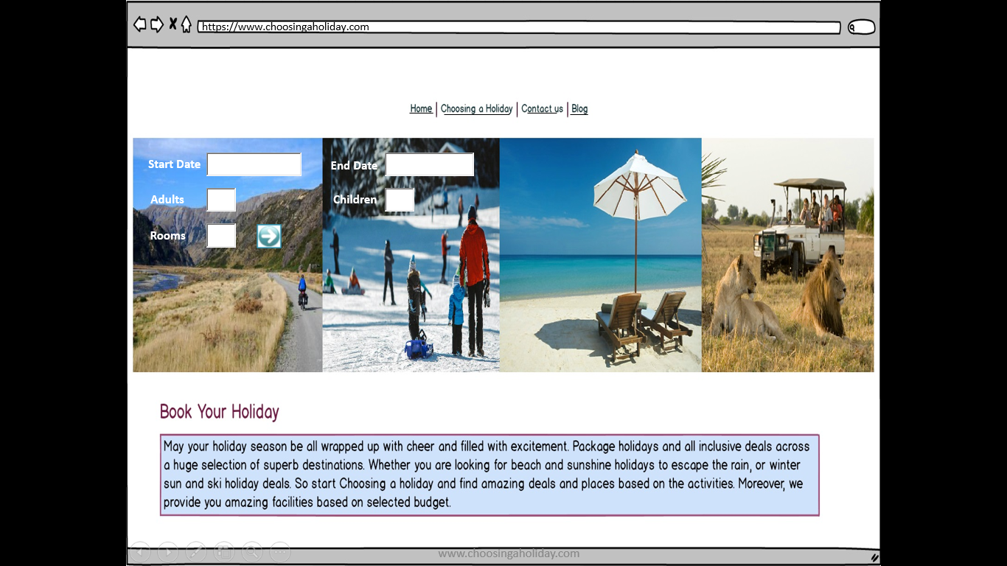

The second page is choosing a holiday so its starts from below page to select what they want to select including budget, activities, and places.

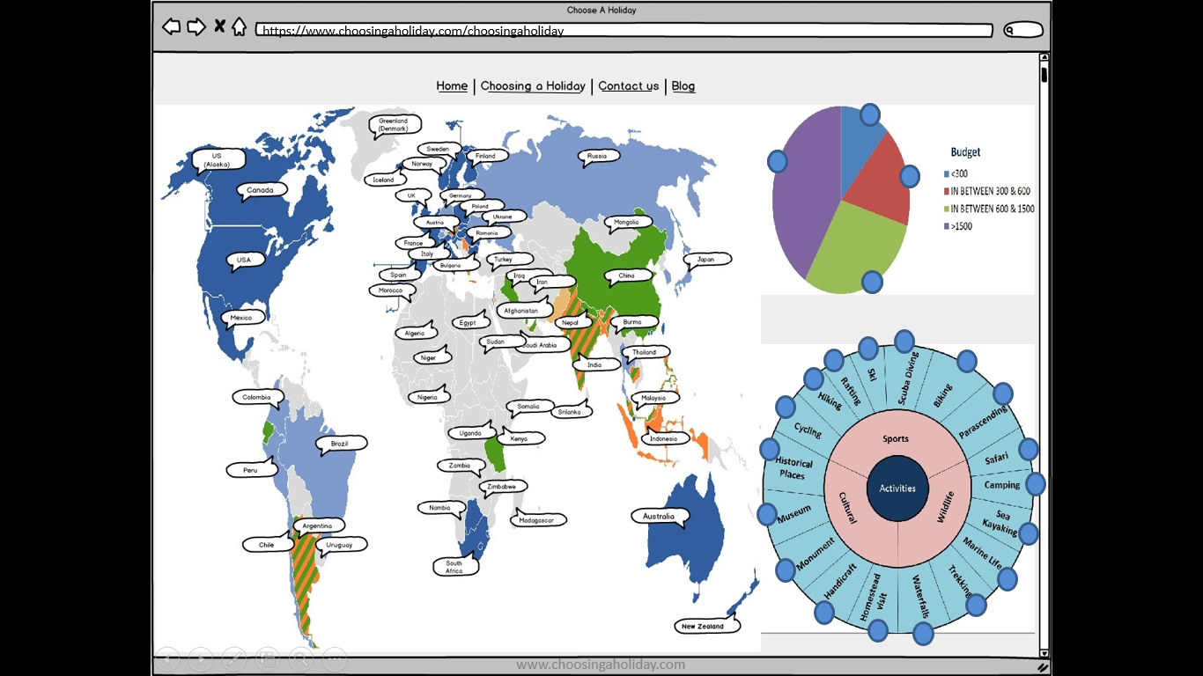

For example, here one of the participant selected first budget which is <300 then they got activities which is they can do in that budget so its pop-up in a yellow colour that means it’s able to do that activities and blue is disable activities means they can’t do in that particular budget. In addition, they selected one of the activities then they got a places within that budget.

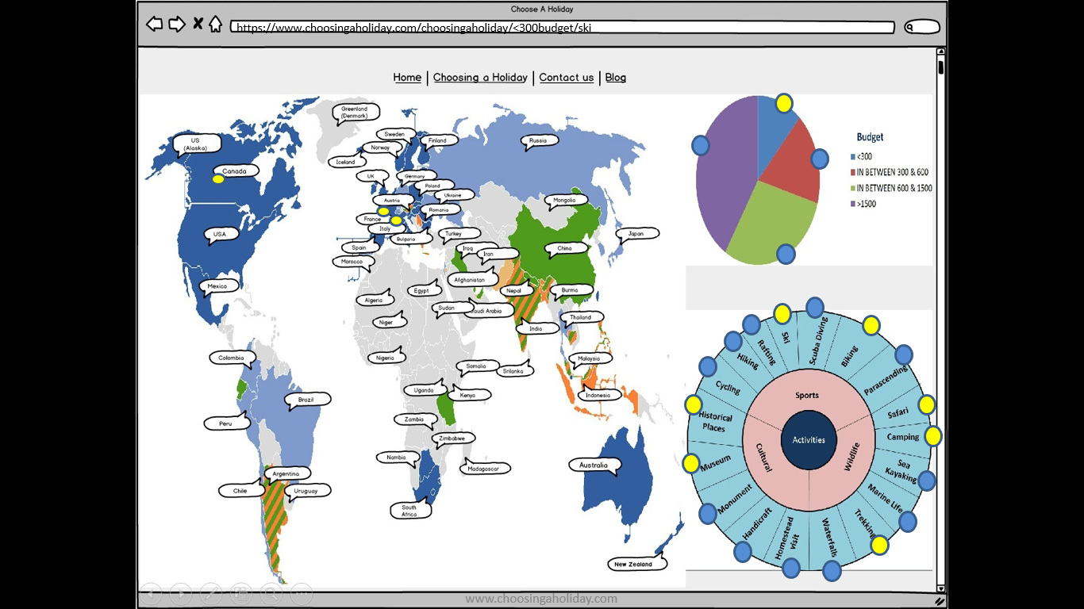

On that based they got facilities based on that budget. 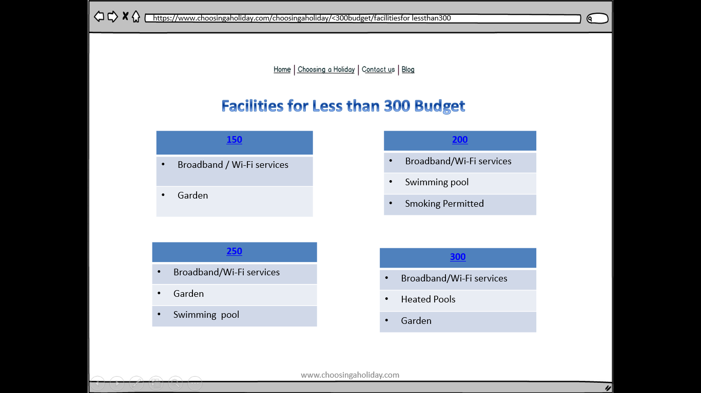

When they conform the budget then they got a conformation page like below page.

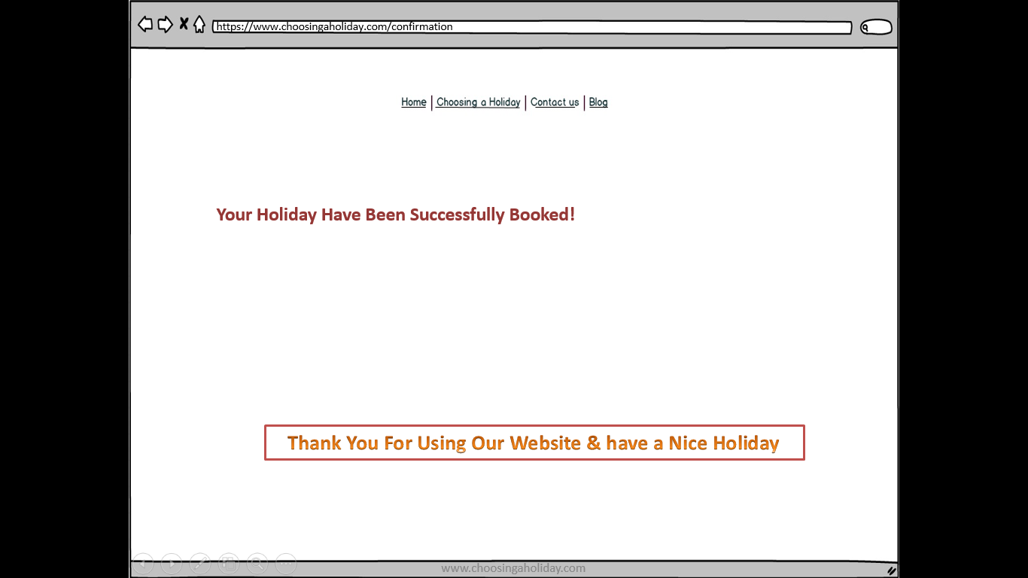

Below is our contact us page of our website.

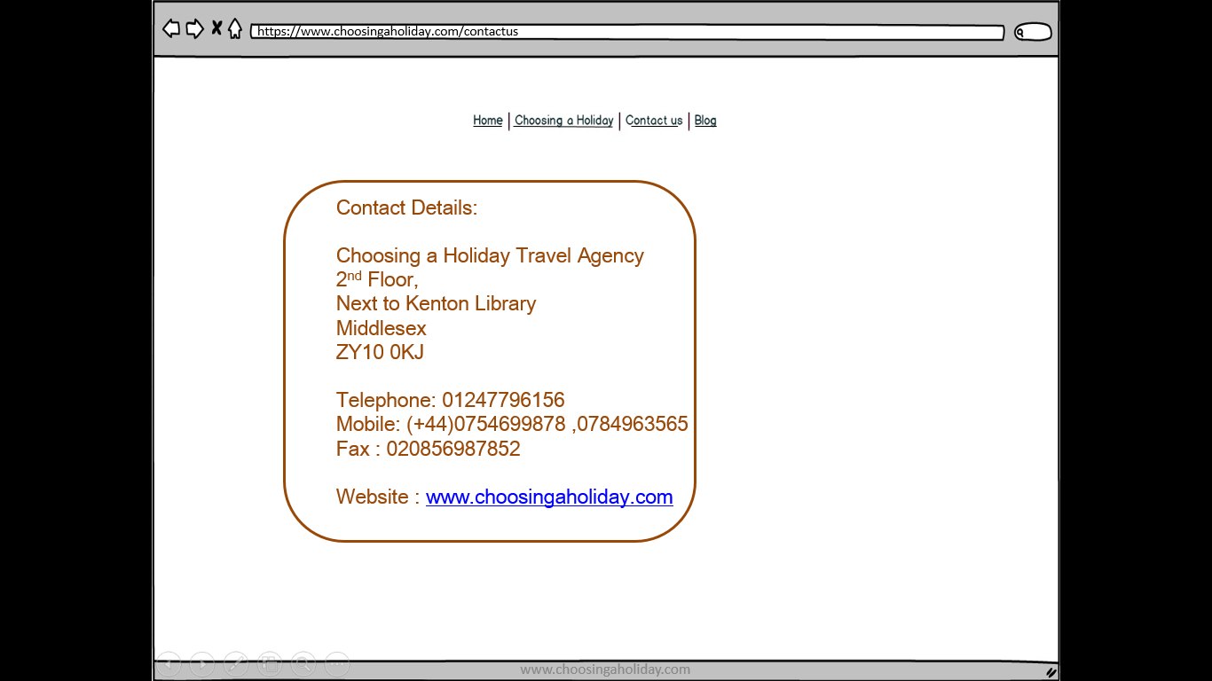

Below is our Blog of our website (Choosing a holiday).

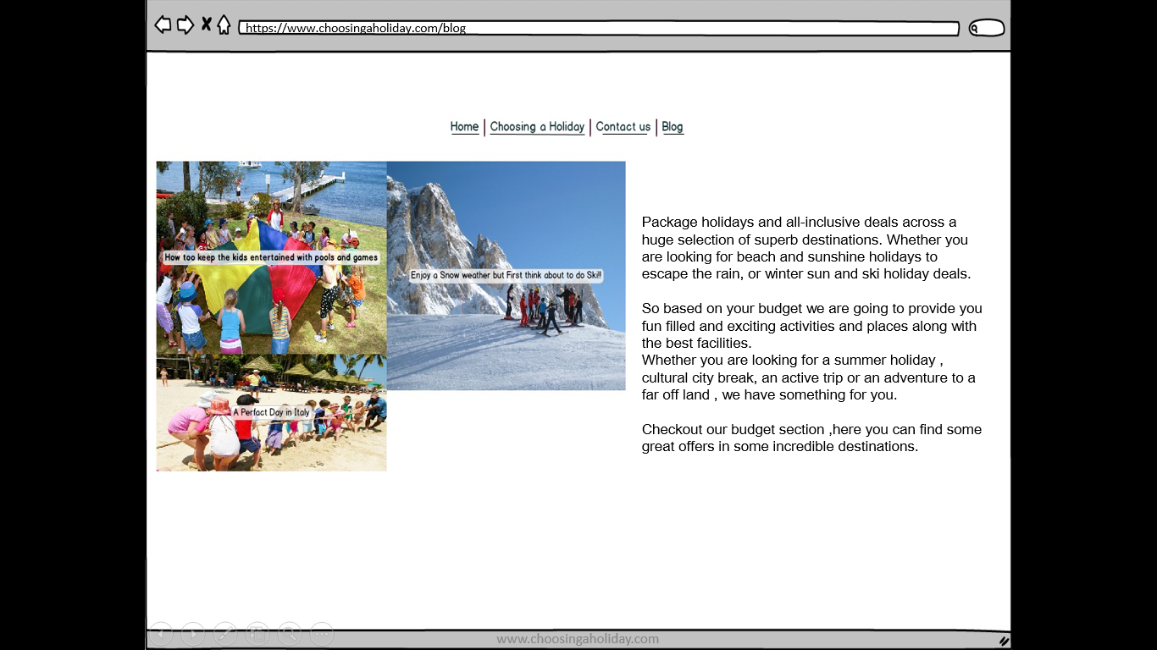

Chapter 5: User evaluation

User evaluation was the most important part of the project. The evaluation step, important information about user experience is obtained. It could lead to possible improvements of the website design and its functionality. That is why is very important to get information from users on this step.

The user evaluation was performed in form of live interview too.

On this step, the evaluation was performed both with the respondents from user research step and new respondents. The respondents were asked if the process of the choosing a holiday with developed prototype is a trouble or not.

The following result of evaluation was achieved:

* Participants feel uncomfortable was not easily start to use the prototype.
* Participants feel uncomfortable was not easily understandable by everyone.
* Calendar is requiring within standard format.
* Make option first for user.
* Link three things together if it is possible (Budget, activity and places).
* Explore places.
* Make indoor and outdoor activities based on weather.
* Budget it should be in scale or slider.
* Make User input first in the form of manually input or visually input.

In addition, the prototype passed user evaluation with good results. But there are some more features and important things that can be added in future.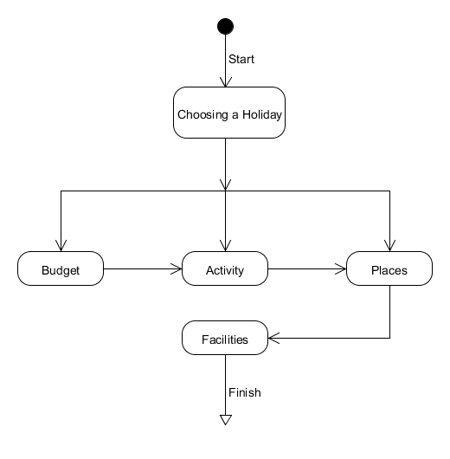

The most important part in this project was spent on different researches, literature studying, develop design and evaluations. So, the following objectives were identified before starting the project:

1. The prototype development.
2. Then study of user experience. Analyse the users and then see what difficulties they find in the prototype so if it is possible then I can changes in future if I am working on this project.
3. Prototype analysis and search of possible ways to improve website functionality and design.

Chapter 6: Discussion

At the finish of this project, a prototype of choosing a holiday was developed first. We passed necessary step in order to create a prototype first and then we take interviews so we got users experience in choosing a holiday. We are going to add all the features and requirement in future if we are working on this prototype. Moreover, according to participant suggested us I trying to solve all the loopholes and vulnerability which was faced by the participant while choosing a holiday in future. In addition, that is possible due to the fact that prototype design is flexible and it can be easily changing by adding new features and functionality.

On the step of user research, the main problems of the choosing a holiday were found. All participants faced same problem like it’s not easy to understand the prototype.

On design stage, the main goal was to develop a good prototype that satisfies user expectation like budget, availability of activities, perfect places for holidays and facilities.

One of the possibilities of three improvements that were found on the discussion step was adding possibility for users to add calendar in a stander format on home page. Some of the people can have problems with use the prototype. Thus it would be great that they like design and some information or options that provide in prototype like (Budget option, Activities option, places).There are a lot of thing that must be done in order to make a completely working project.

Reference

1. <http://nccur.lib.nccu.edu.tw/bitstream/140.119/33943/7/93303907.pdf>
2. <http://www.scribblelive.com/blog/2012/08/06/interaction-design-for-data-visualizations/>
3. <https://openlab.ncl.ac.uk/wp-content/uploads/2011/01/coop_run_time.pdf>
4. https://Information-Visualization-Design-Interaction-2nd/dp/0132065509